Learning Goals
By the end of this activity, you will be able to:
- Interact with Hadoop using the command-line application.
- Copy files into and out of the Hadoop Distributed File System (HDFS).

Instructions
1. Open a browser. Open the browser by click on the browser icon on the top left of the screen.


2. Download the Shakespeare. We are going to download a text file to copy into HDFS. Enter the following link in the browser: http://ocw.mit.edu/ans7870/6/6.006/s08/lecturenotes/files/t8.shakespeare.txt
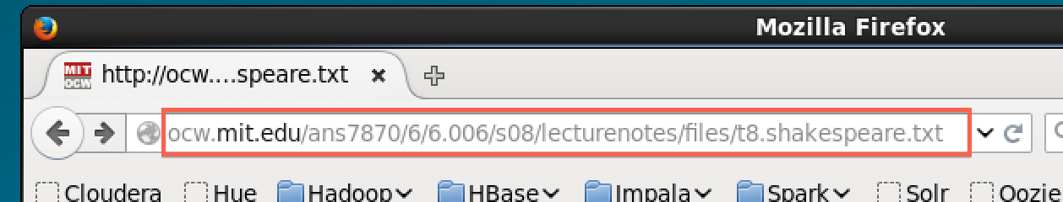
Once the page is loaded, click on the Open menu button.

Click on Save Page
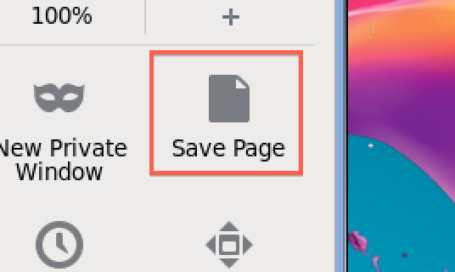
Change the output to words.txt and click Save.
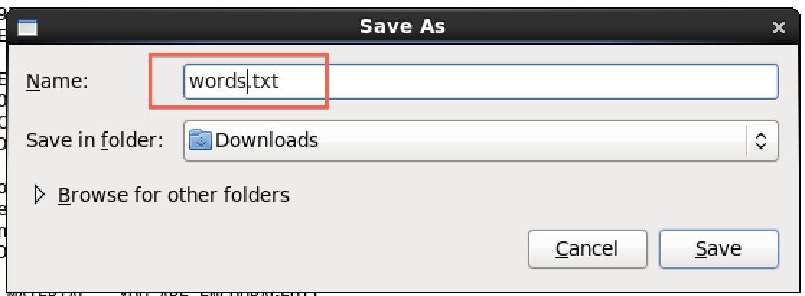

2. Open a terminal shell. Open a terminal shell by clicking on the square black box on the top left of the screen.

Run cd Downloads to change to the Downloads directory.
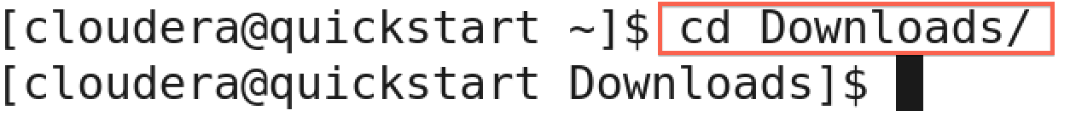
Run ls to see that words.txt was saved.
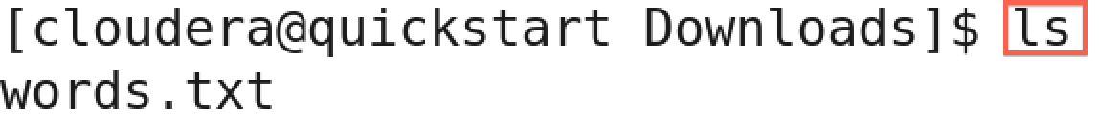
3. Copy file to HDFS. Run hadoop fs –copyFromLocal words.txt to copy the text file to HDFS.
4. Verify file was copied to HDFS. Run hadoop fs –ls to verify the file was copied to HDFS.
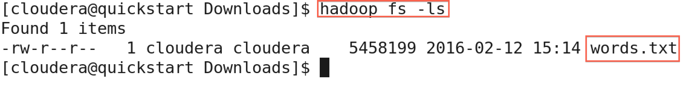
5. Copy a file within HDFS. You can make a copy of a file in HDFS. Run hadoop fs -cp words.txt words2.txt to make a copy of words.txt called words2.txt
We can see the new file by running hadoop fs -ls
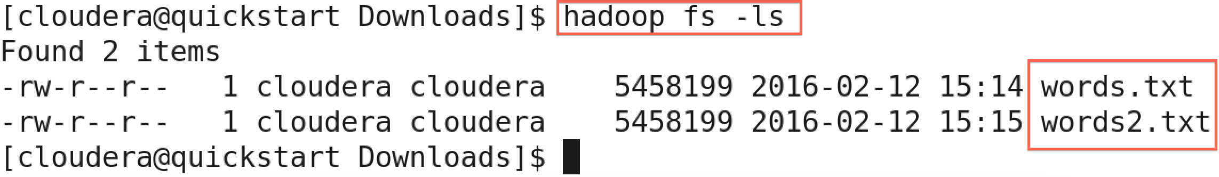
6. Copy a file from HDFS. We can also copy a file from HDFS to the local file system. Run hadoop fs -copyToLocal words2.txt . to copy words2.txt to the local directory.
Let's run ls to see that the file was copied to see that words2.txt is there.
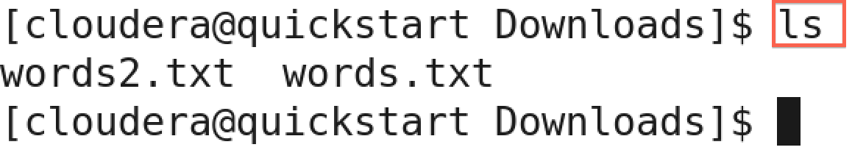
7. Delete a file in HDFS. Let's the delete words2.txt in HDFS. Run hadoop fs -rm words2.txt
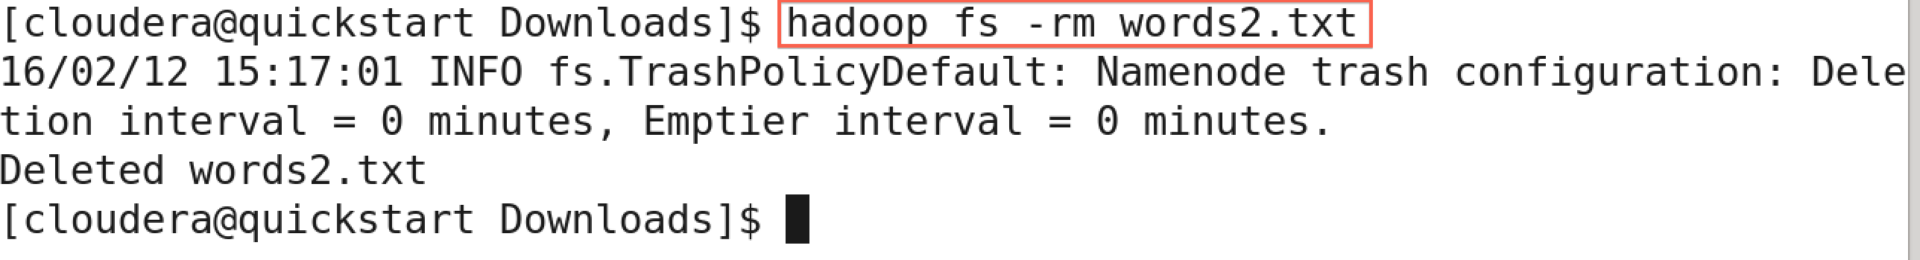
Run hadoop fs -ls to see that the file is gone.
